*NucE 497 Fuel Performance Exam 2 covering modules 4 – 6*

*Name:*

**Question 1 (25 points):**

The temperature and gap width of a fuel pellet, as predicted by a fuel performance code, is shown below. Using the plots as your guide, determine what is currently occurring within the cladding, gap, and pellet at each number. Note that the numbers are at the same burnups on the two plots.

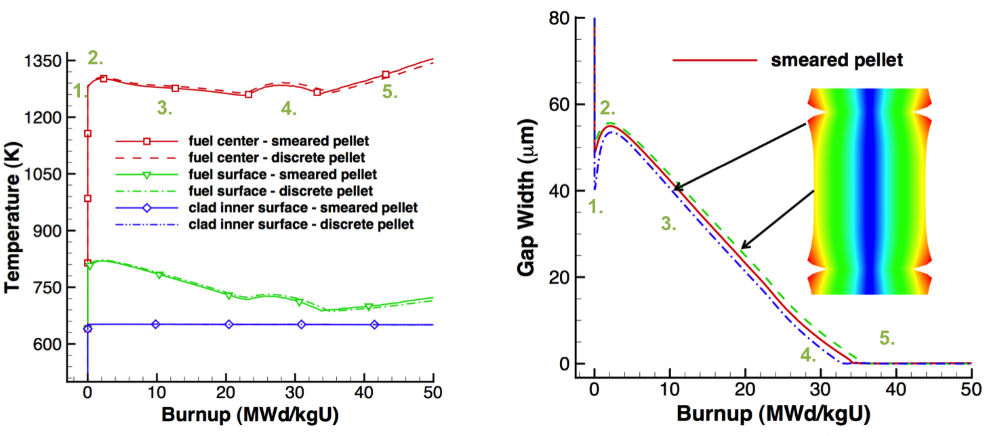

For each number, describe what is occurring in the cladding, gap, and pellet. Also, describe what features in the plots indicated these behaviors.

1.

2.

3.

4.

5.

**Question 2 (30 points)**

A fuel pellet with an average grain size of 8 microns is irradiated with a volumetric neutron flux of 2.0e13 fissions/(cm3 s). Assume the pellet is at a uniform temperature of 900 °C.

1. What is the fission gas diffusion coefficient at this temperature? (5 pts)
2. How many gas atoms/cm3 are released from the fuel after 2 years of irradiation? Assume the chain yield y = 0.3017. (10 pts)
3. After 2 years of irradiation, the pellet is removed from the reactor and from its cladding, venting all released gas. It is then moved to a furnace and annealed at 2000 °C. Estimate how long before 10% of the gas trapped in the pellet is released. How many gas atoms/cm3 will have been released during this time? (15 pts)

**Problem 3 (30 points)**

A ZIRLO cladding tube is in reactor at 600 K for one year. The initial wall thickness is 0.6 mm.

1. What is the oxide weight gain in mg/dm2 after this time? (10 pts)
2. What is the ZIRLO wall thickness after this time? (5 pts)
3. Assuming the hydrogen pickup fraction is 15%, what is the weight PPM of hydrogen in the cladding after one year? (10 pts)
4. Draw a section of the cladding, showing the various microstructure changes (5 pts)

**Problem 4 (15 points)**

1. What are the primary differences between a loss of coolant accident and a reactivity insertion accident, regarding the fuel and cladding behavior? (5 pts)
2. What are similarities between the fuel and cladding behavior in a RIA and a LOCA? (5 pts)
3. List a potential accident tolerant fuel concept and describe how it could meet the primary goal of the accident tolerant fuel program. (5 pts)